EXPERIMENT 6
ONLINE CAKE ORDERING SYSTEM
AIM:
To design and develop a simple Online Cake Ordering System using HTML, CSS, and JavaScript with login, cake search, filtering, cart, order placement, shipping address, and admin order management.
CODE:
<!DOCTYPE html>
<html>
<head>
<title>Online Cake Ordering</title>
<style>
body{font-family:Arial;background:#fff0f5;text-align:center}
.box{background:white;padding:15px;margin:15px auto;max-width:700px}
input,select,button{padding:10px;margin:5px}
button{background:#d6336c;color:white;border:0}
.cake{display:inline-block;padding:15px;margin:10px;border:1px solid #ccc}
.hide{display:none}
</style>
</head>
<body>
<h1>🎂 Online Cake Ordering</h1>
<div id="login" class="box">
<input id="u" placeholder="Username">
<input id="p" type="password" placeholder="Password">
<button onclick="login()">Login</button>
<p>Admin: admin / 1234</p>
</div>
<div id="customer" class="box hide">
<h2>Customer Dashboard</h2>
<input id="search" placeholder="Search Cake" onkeyup="show()">
<select id="cat" onchange="show()">
<option value="">All</option>
<option>Birthday</option>
<option>Chocolate</option>
<option>Wedding</option>
</select>
<div id="cakes"></div>
<h3>🛒 Cart</h3>
<div id="cart">Empty</div>
<input id="addr" placeholder="Shipping Address">
<button onclick="order()">Place Order</button>
<h3>📦 My Order</h3>
<div id="orders">No orders</div>
</div>
<div id="admin" class="box hide">
<h2>Admin Dashboard</h2>
<input id="name" placeholder="Cake Name">
<input id="price" placeholder="Price">
<input id="category" placeholder="Category">
<button onclick="add()">Add Cake</button>
<h3>Manage Products</h3>
<div id="products"></div>
<h3>Manage Orders</h3>
<div id="adminOrders">No orders</div>
</div>
<script>
let cakes=[
{name:"Chocolate Cake",price:500,cat:"Chocolate"},
{name:"Birthday Cake",price:700,cat:"Birthday"},
{name:"Wedding Cake",price:1200,cat:"Wedding"}
];
let cart=[],orders=[];
function login(){
if(u.value=="admin"&&p.value=="1234"){
loginDiv(false);admin.classList.remove("hide");products.innerHTML=cakes.map(x=>x.name+" ₹"+x.price).join("<br>");
}else{
loginDiv(false);customer.classList.remove("hide");show();
}
}
function loginDiv(x){
document.getElementById("login").style.display=x?"block":"none";
}
function show(){
let s=search.value.toLowerCase(),c=cat.value;
cakesDiv="";
cakes.filter(x=>x.name.toLowerCase().includes(s)&&(!c||x.cat==c))
.forEach((x,i)=>cakesDiv+=`<div class=cake>
<b>${x.name}</b><br>₹${x.price}<br>
<button onclick="cart.push(cakes[${i}]);showCart()">Add</button></div>`);
document.getElementById("cakes").innerHTML=cakesDiv;
}
function showCart(){
document.getElementById("cart").innerHTML=
cart.map(x=>x.name+" ₹"+x.price).join("<br>");
}
function order(){
if(!cart.length||!addr.value)return alert("Add cake and address");
let total=cart.reduce((a,x)=>a+x.price,0);
orders.push({name:cart.map(x=>x.name),total:total,status:"Order Placed"});
cart=[];showCart();showOrders();
}
function showOrders(){
document.getElementById("orders").innerHTML=
orders.map((x,i)=>`Order ${i+1}: ${x.name}<br>
₹${x.total} - ${x.status}`).join("<hr>");
adminOrders.innerHTML=orders.map((x,i)=>
`Order ${i+1} - ${x.status}
<select onchange="orders[${i}].status=this.value">
<option>Order Placed</option>
<option>Processing</option>
<option>Shipped</option>
<option>Delivered</option>
</select><hr>`).join("");
}
function add(){
cakes.push({name:name.value,price:price.value,cat:category.value});
products.innerHTML=cakes.map(x=>x.name+" ₹"+x.price).join("<br>");
alert("Cake Added");
}
</script>
</body>
</html>

OUTPUT:
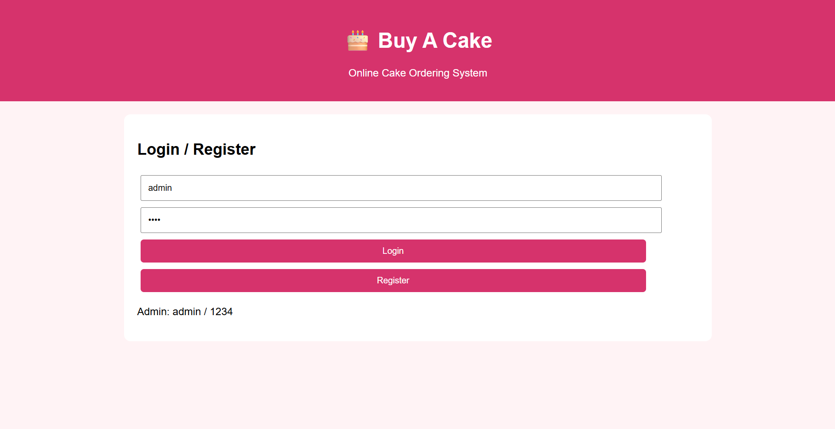
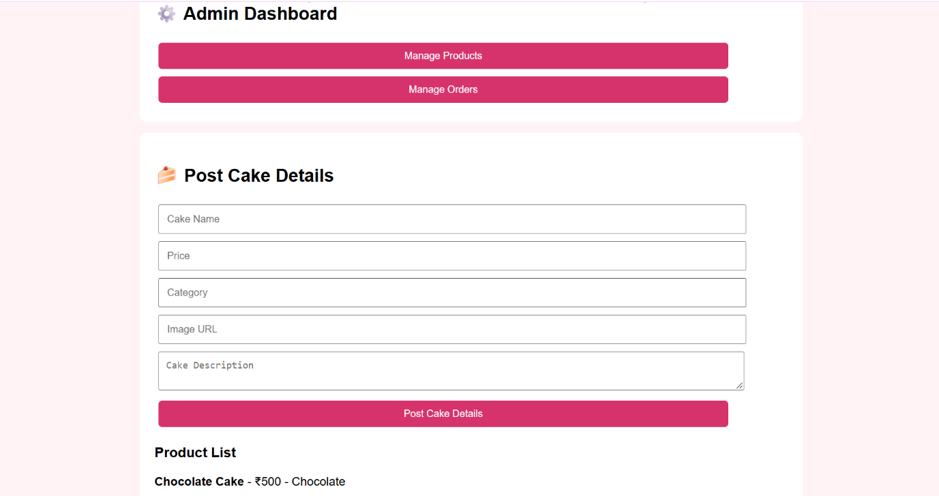
RESULT:
Thus, the Online Cake Ordering System was successfully designed and implemented using HTML, CSS, and JavaScript. The system supports customer login, cake search, filtering, cart, order placement, shipping address, and admin product/order management.

